Progress Report 2
- IBP Project: Intelligent Business Performance Analytics and Decision Support Platform For Small Business
- Student: Hugh Tran
- SID: 300394597
- Reporting Date: March 2, 2026
Project Objectives
The goal of this project is to build a Business Intelligence (BI) platform that helps users understand sales performance and customer opinions. The system uses sales data and customer review data to support analysis, forecasting, and sentiment analysis. The results will be shown through a web interface and Power BI dashboards.
Work Completed So Far
- Built frontend for dashboards
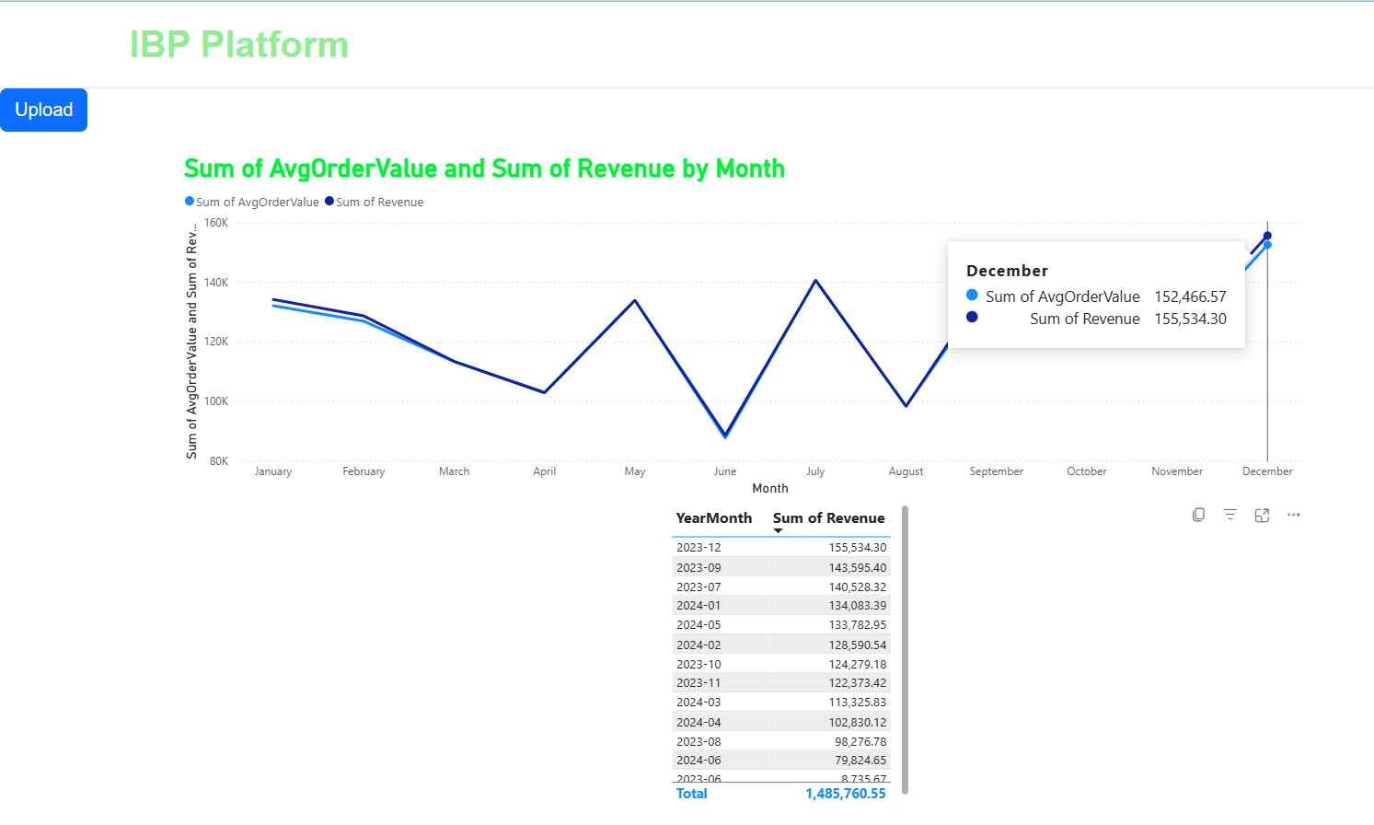
The frontend was developed to display the dashboard in the web application. HTML pages were designed, and navigation buttons were created so users can easily move between the upload page and the dashboard page. The layout was arranged clearly so users can upload data and then open the dashboard without confusion. The interface was tested to make sure it works properly.

- Connected SQL Server with PowerBI
The connection between SQL Server and Power BI was set up to show data in reports. The database connection was set up and the correct server name was checked. Data from the raw, clean, and analytics tables can now be seen in Power BI for reporting.
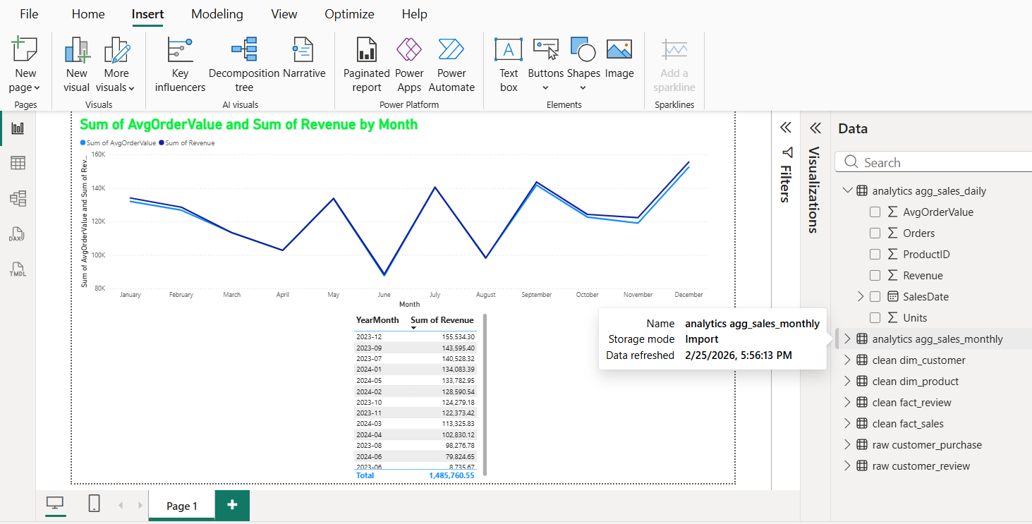

- Embedded PowerBI dashboards into the frontend
Different embedding options were explored and a suitable method was selected. The Power BI dashboard was integrated into the HTML page and tested within the FastAPI application. Permission and display issues were resolved to ensure the dashboard loads correctly and functions as expected.
Next Steps
The next steps of the project are planned as follows:
- Complete KPIs dashboard format and the related frontend; develop sales forecasting feature (to March 8, 2026)
- Develop business recommendation based on sales performance; research on applying NLP to customers’ review (from March 9 to March 15, 2026)
- Perform sentiment analysis on customer reviews (after step 2)
- Generate business review report (after step 3)
- Write the final project report (after step 4)

Project Planning and Timeline
Time | Milestone | Actions
Feb 23 – Mar 8, 2026 | Business Analytics & Dashboard | - Define and calculate key business KPIs such as revenue, sales volume, and average order value (in progress)  - Perform product-level and time-based performance analysis (in progress)  - Build dashboards to show trends and comparisons (in progress)  - Enable time-range filtering for analytics (in progress)  - Build interactive frontend (in progress)
Mar 2 – Mar 22, 2026 | Forecast & Recommendation | - Train forecasting models using historical sales data  - Generate future sales forecasts  - Compare forecast results with historical performance  - Produce basic business recommendations based on analytics and forecasts
Mar 9 – Mar 29, 2026 | Reporting & UI Interaction | - Generate automated business review reports  - Combine KPIs, trends, forecasts, and recommendations into clear reports  - Allow users to select time ranges when generating reports  - Present analytical results clearly through the user interface
Mar 30 – Apr 5, 2026 | Final review | - Review and validate all system components  - Test the accuracy of analytics and report outputs  - Finalize documentation and the research report  - Prepare for project presentation

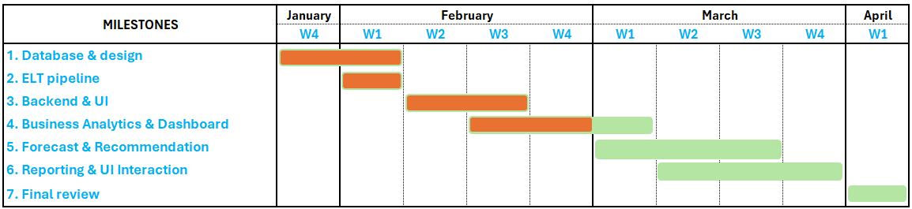

Work log
Date | Number of Hours | Description
Feb 24, 2026 | 2 | - Built frontend for presenting dashboard  - Researched HTML navigation in FastAPI
Feb 25, 2026 | 1 | - Connected SQL server and PowerBI
Feb 26, 2026 | 2 | - Embeded PowerBI dashboard to front-end
March 2, 2026 | 3 | - Researched sales KPIs for business  - Wrote progress report 2

AI use section
AL Tool Name | Version, Account Type | Specific feature for which the AI tool was used | Value addition
ChatGPT | GPT-5.2 plus | Suggested general approaches for integrating dashboards; configured FastAPI routes | I designed the HTML structure, handled button actions
 |  | Explained how to connect SQL Server to Power BI and gave some basic troubleshooting ideas
 |  | Suggested embedding options from PowerBI to frondend | Selected the appropriate embedding approach, handled school account limitations, resolved permission issues
 |  | Improved grammar, sentence structure, and clarity of the progress report | Selected relevant technical content, ensured alignment with actual implementation, validated accuracy of explanations, structured the report according to assignment requirements, and maintained consistency between system design and documentation

Prompt Appendix
in next step of IBP, i want to build interactive frontend to display powerBI dashboard, let generate code
class="btn btn-lightgreen" => lightgreen correct?
why cannot navigate between html pages
how to do html navigation in fastApi?
why the dashboard.html returned {“detail:”Not found”} ?
review these above code
how to resolve port conflict?
it worked with <a href="/dashboard" class="btn btn-lightgreen">Open Power BI Dashboard</a>, but not worked with <button onclick="goDashboard()" class="btn btn-primary"> Open Dashboard </button> => how it work with button
how to connect sql server and powerBI
why the connection fail?” how to fix?
provide step by step for each option
how can i embed dashboard in powerBI to frontend html
i'm using school account, how can i switch to personal account to avoid admin permission
when publishing to PowerBI, having this problem when connect to powerBI service
not work with "Public to web(public)", can i use "website or portal" instead?
Wording these paragraphs

